Task 1: Launch EC2 using Amazon Linux 2 and Install Apache using User Data
Step 1: Login to AWS
- Go to AWS Console → https://console.aws.amazon.com
- Search EC2 → Open EC2 Dashboard.
Step 2: Launch Instance
- Click Launch Instance.
- Name: AmazonLinux-Apache
- AMI: Select Amazon Linux 2.
- Instance Type: t2.micro (Free tier eligible).
- Key Pair: Create or select existing.
Step 3: Add User Data Script
- Scroll to Advanced Details → User Data.
- Paste below script:
- #!/bin/bash
- yum update -y
- yum install httpd -y
- systemctl start httpd
- systemctl enable httpd
- echo "Apache Installed Successfully" > /var/www/html/index.html

Step 4: Configure Security Group
- Allow HTTP (Port 80)
- Allow SSH (Port 22)
Step 5: Launch Instance
- Click Launch.
- Copy Public IP → Open in browser → Verify Apache page.

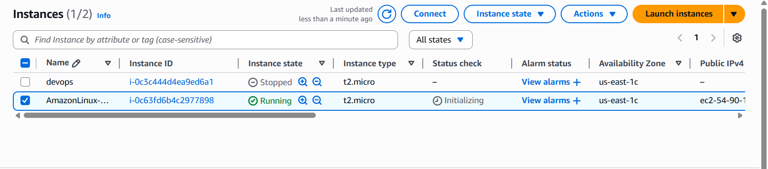

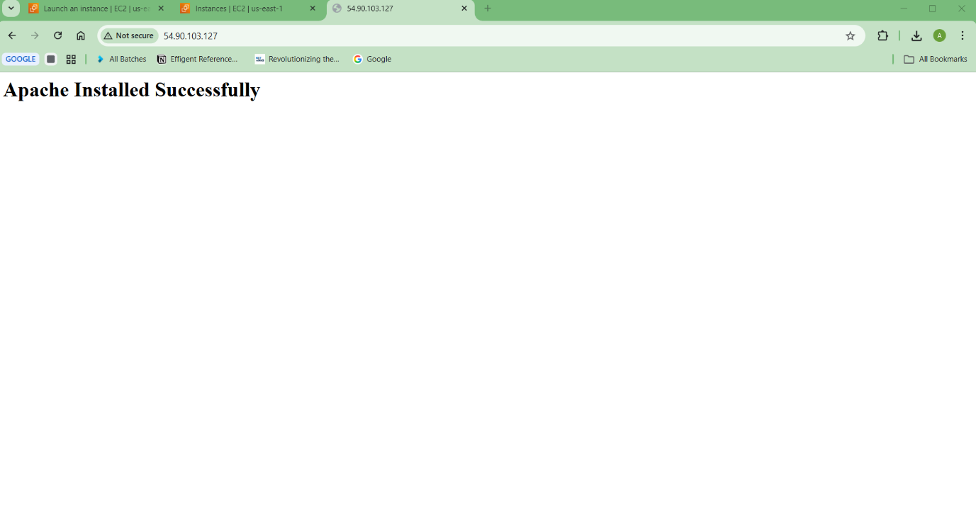
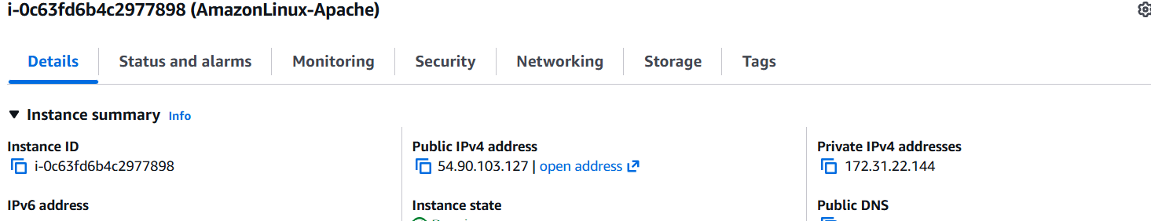

Task 2: Launch EC2 using Ubuntu and Install Nginx using User Data
Step 1: Launch Instance
- EC2 → Launch Instance.
- Name: Ubuntu-Nginx
- AMI: Ubuntu Server.
- Instance Type: t2.micro.
- Select Key Pair.
Step 2: Add User Data Script
#!/bin/bash
apt update -y
apt install nginx -y
systemctl start nginx
systemctl enable nginx
Step 3: Security Group
- Allow HTTP (80)
- Allow SSH (22)
Step 4: Launch → Check Public IP in browser.

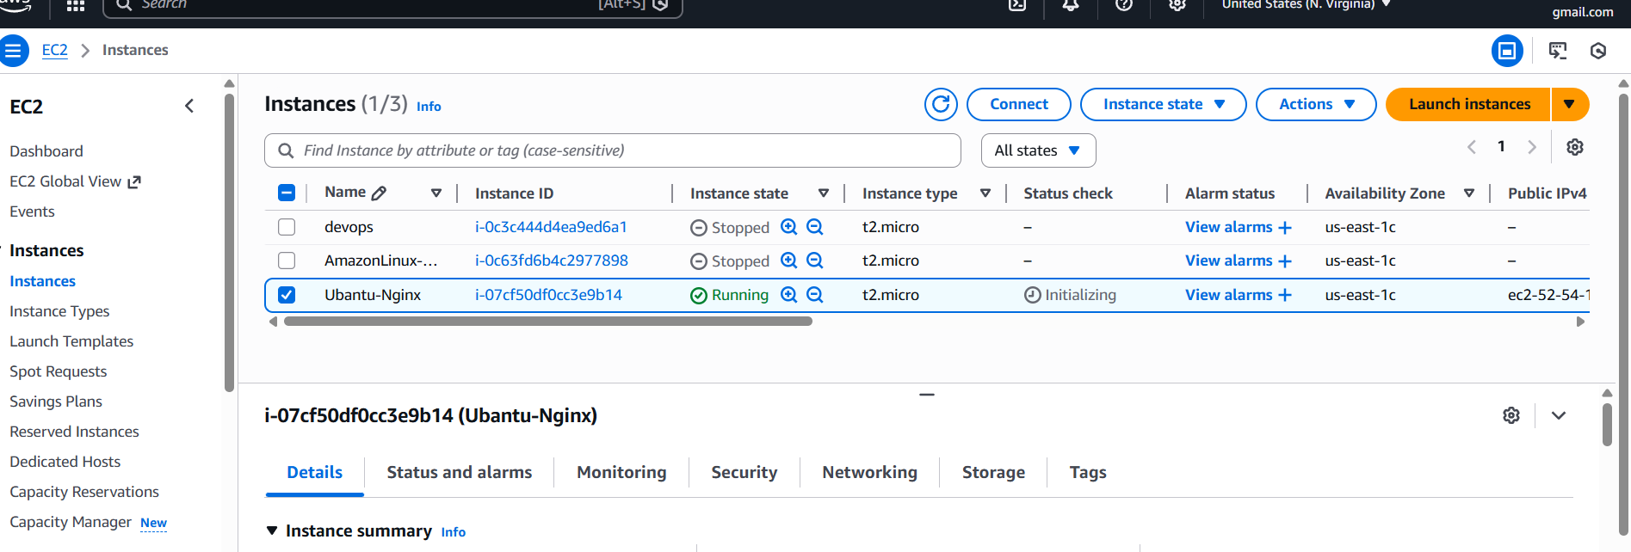

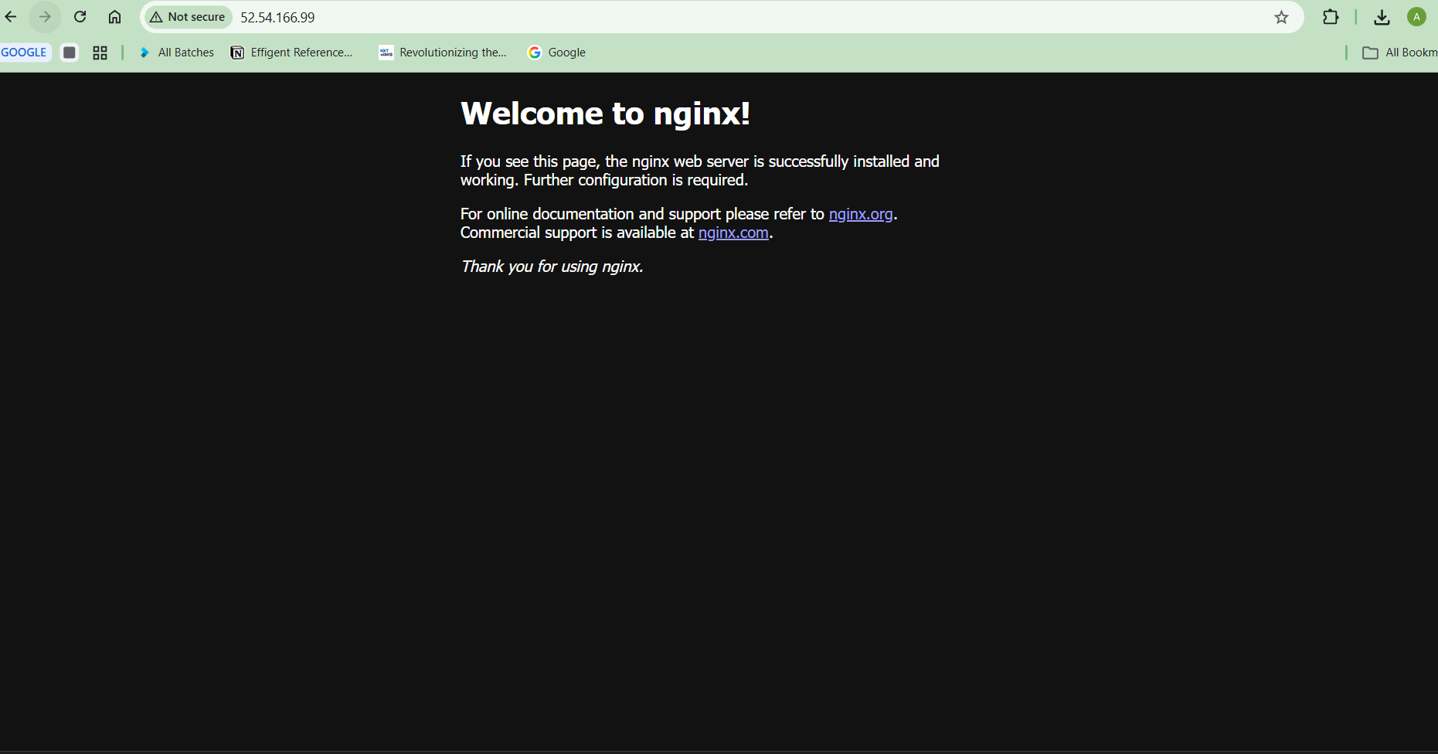

Task 3: Launch Windows Server and Install Tomcat
Step 1: Launch Windows Instance
- EC2 → Launch Instance.
- Name: Windows-Tomcat
- AMI: Windows Server 2019/2022.
- Instance Type: t2.micro or t3.micro.
- Allow RDP (3389).
Step 2: Connect to Windows
- Select Instance → Connect → RDP Client.
- Download RDP file.
- Get Administrator Password using key pair.

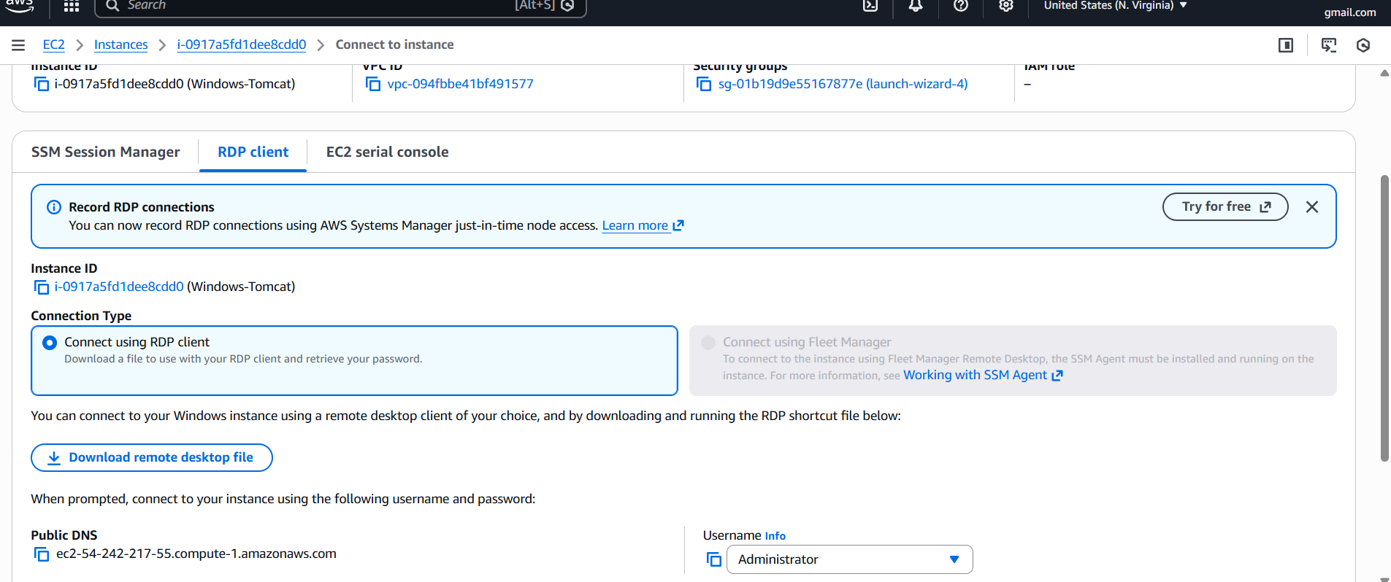
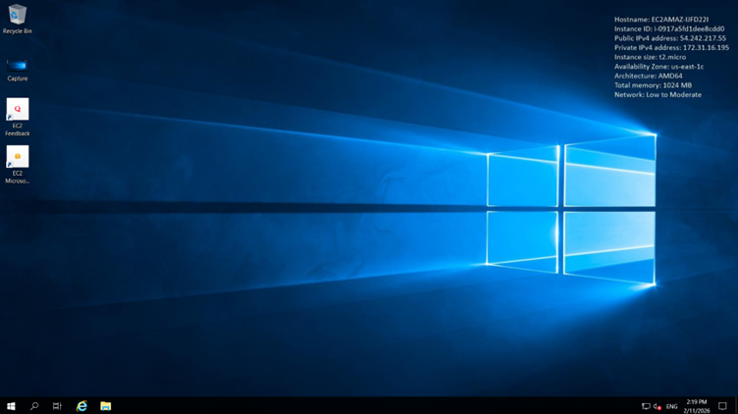

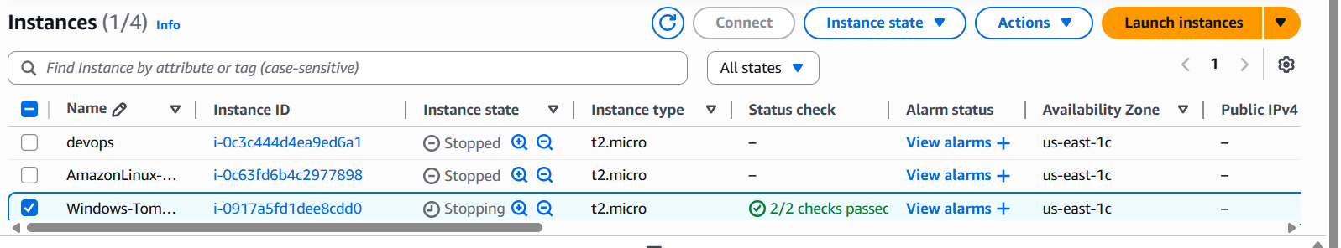

Step 3: Install Java
- Download JDK from Oracle website.
- Install and set JAVA_HOME.
Step 4: Install Apache Tomcat
- Download Tomcat zip.
- Extract → Open bin folder.
- Run startup.bat.
- Open browser:

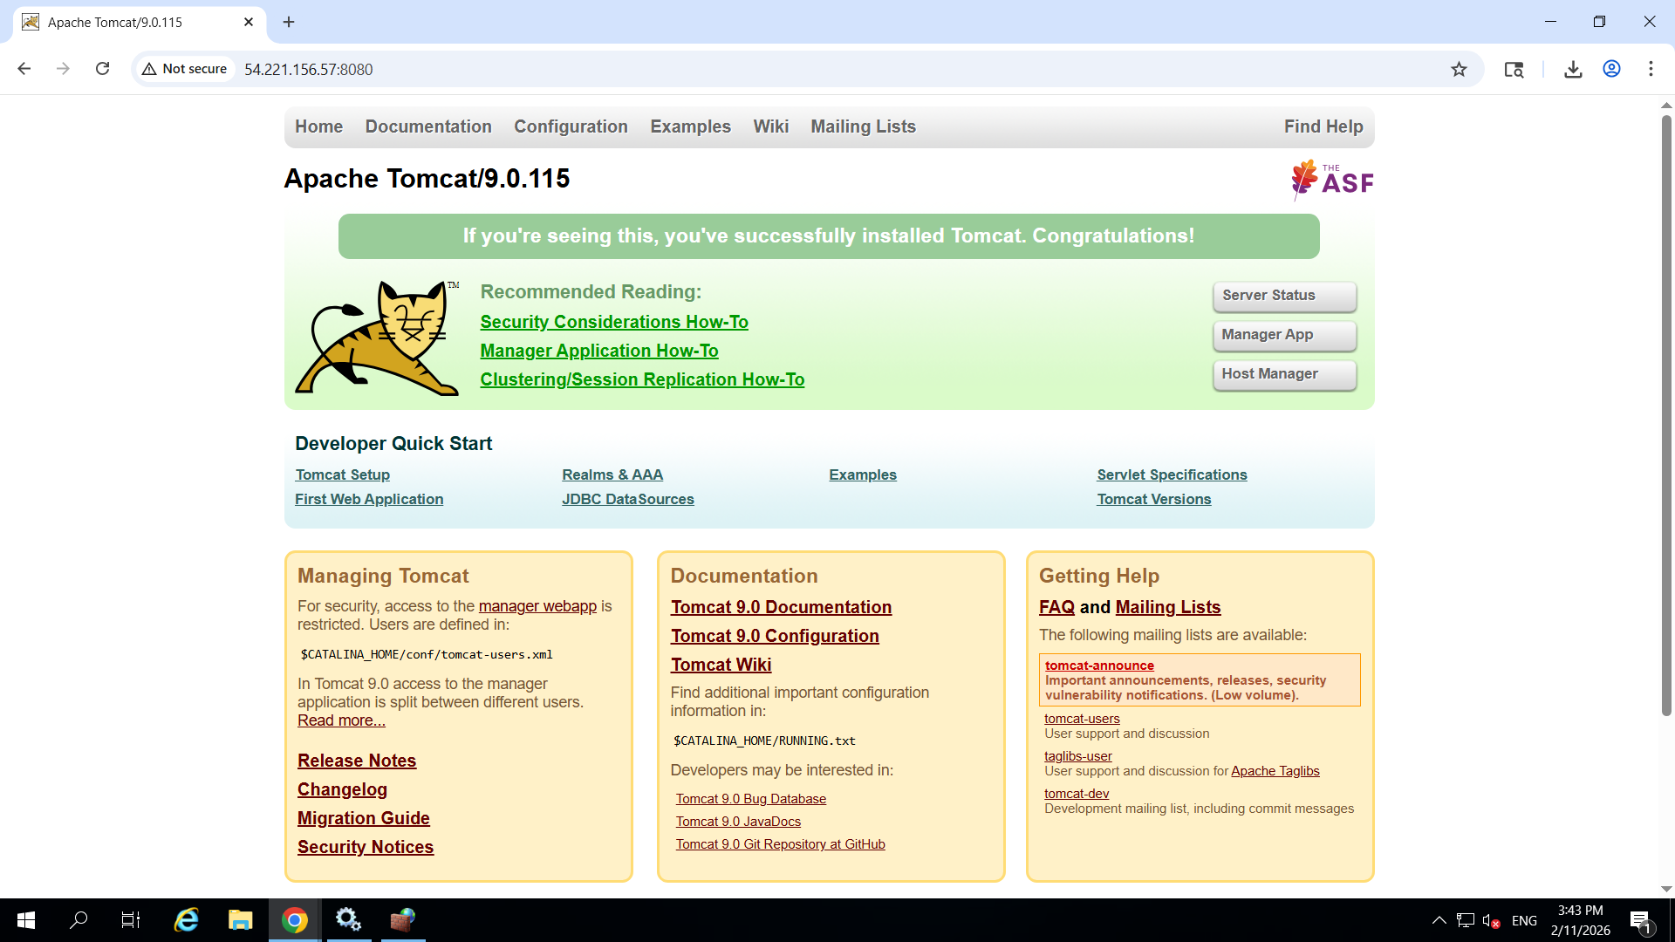

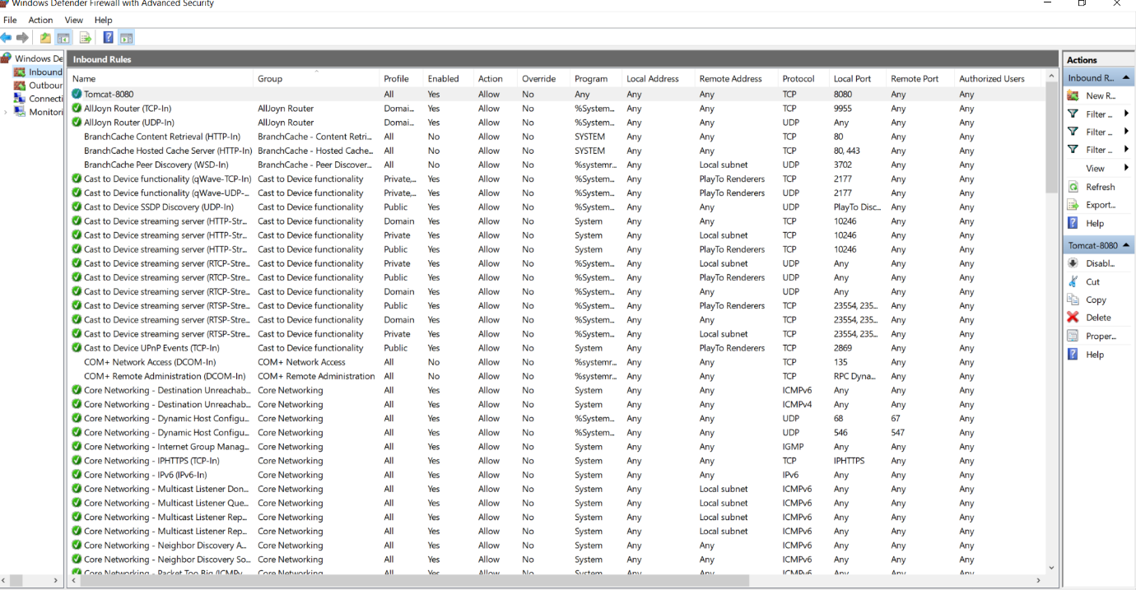

Take Snapshot of Instance from Task 1
Step 1:
- EC2 → Instances.
- Select AmazonLinux-Apache instance.
Step 2:
- Storage tab → Click Volume ID.
Step 3:
- Actions → Create Snapshot.
- Provide name → Create.

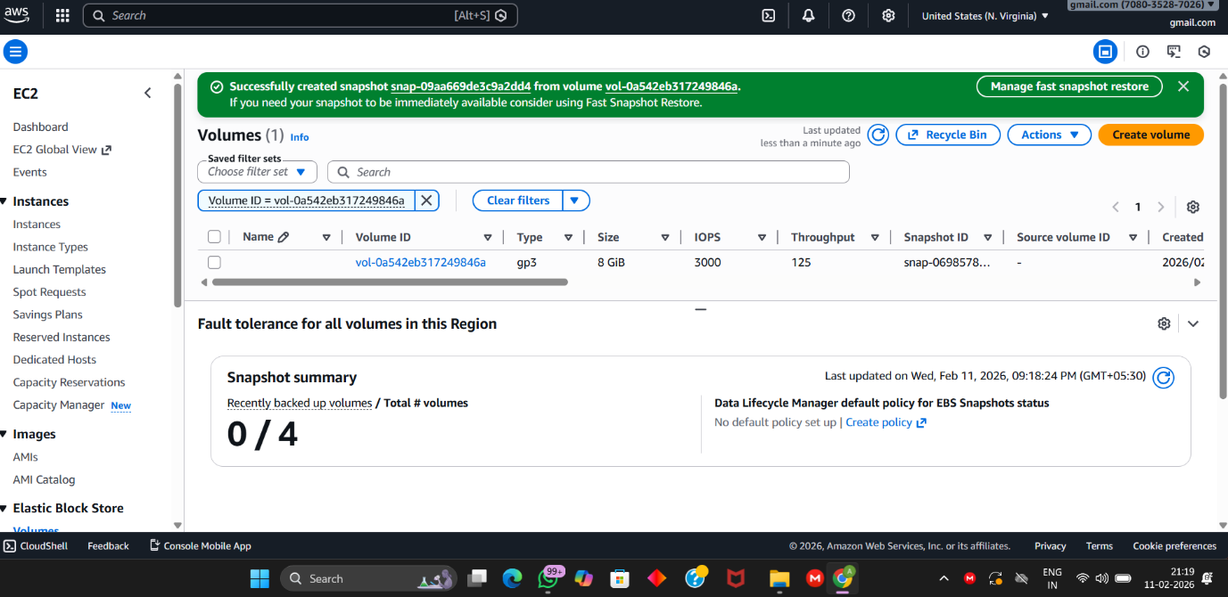

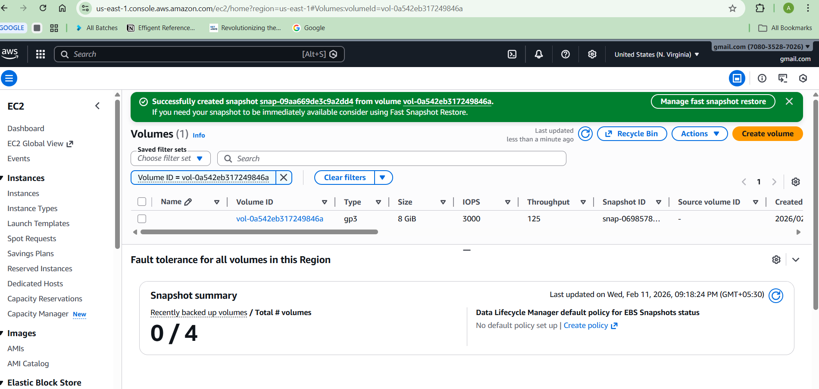
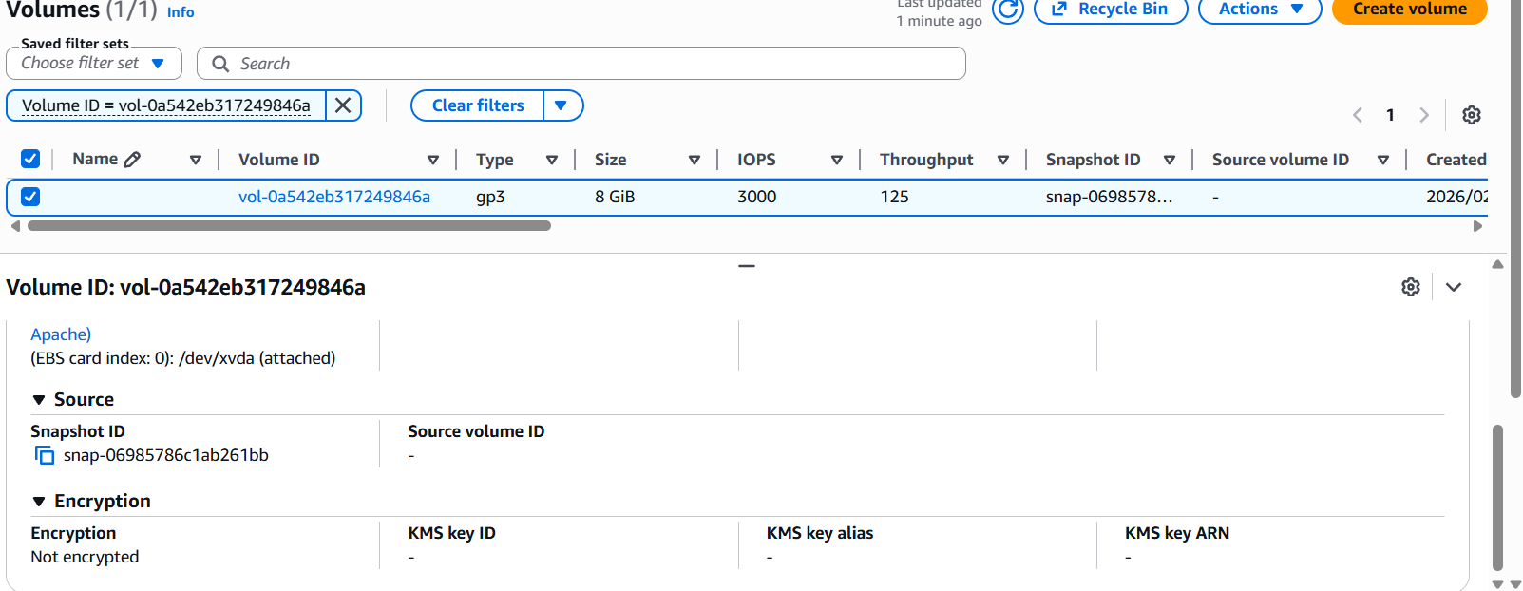

Task 5: Assign Passwordless Authentication for EC2 (Task 2 Ubuntu)
Step 1: Connect to Instance
ssh -i key.pem ubuntu@public-ip
Step 2: Generate SSH Key
ssh-keygen

cat ~/.ssh/id_rsa.pub >> ~/.ssh/authorized_keys
Now password Less authentication enabled.
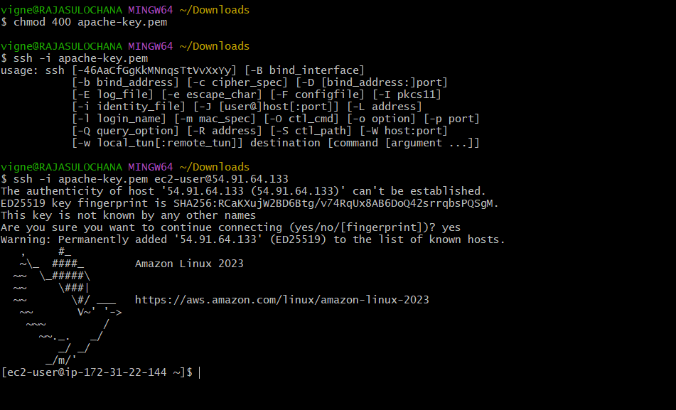

Task 6: Launch EC2 using Spot Instance
Step 1:
- EC2 → Launch Instance.
Step 2:
- Expand Advanced Options.
- Purchasing Option → Select Spot Instance.
Step 3:
- Launch Instance.
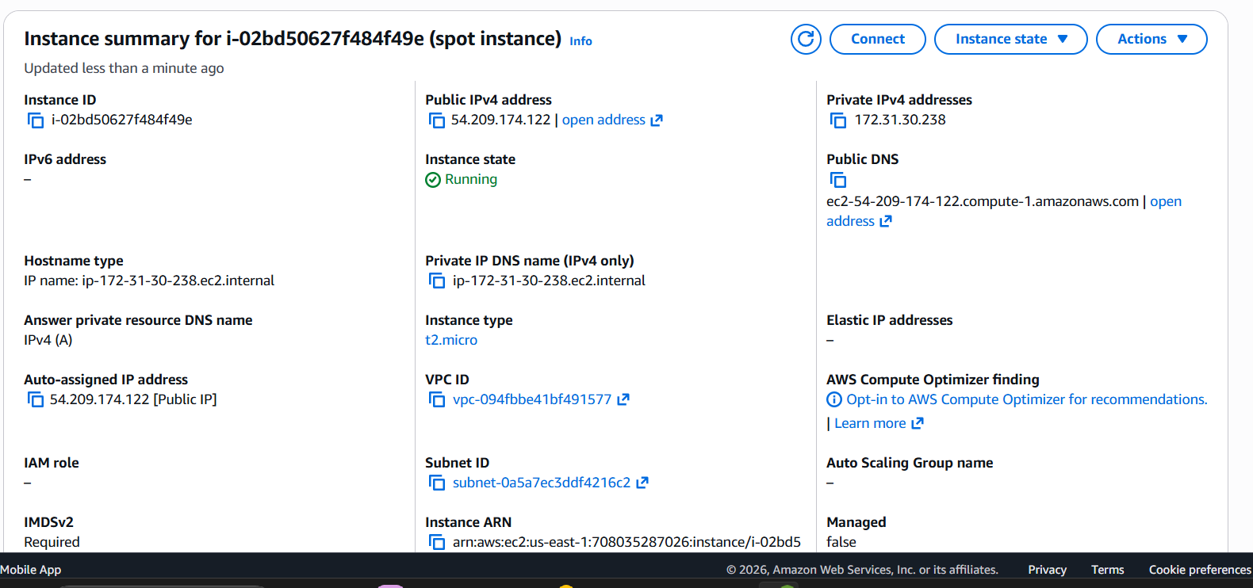

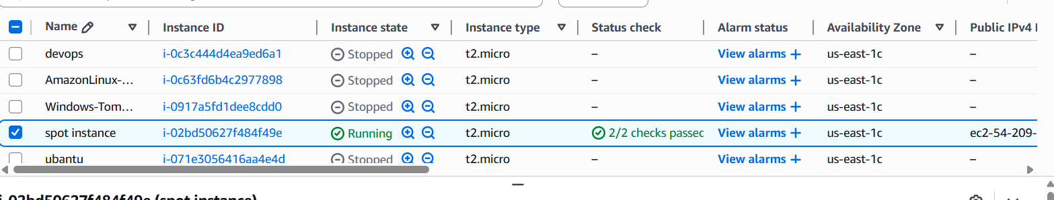

Task 7: Enable Termination Protection (Task 2 Instance)
Step 1:
- EC2 → Instances.
- Select Ubuntu instance.
Step 2:
- Actions → Instance Settings → Change Termination Protection.
- Enable → Save.

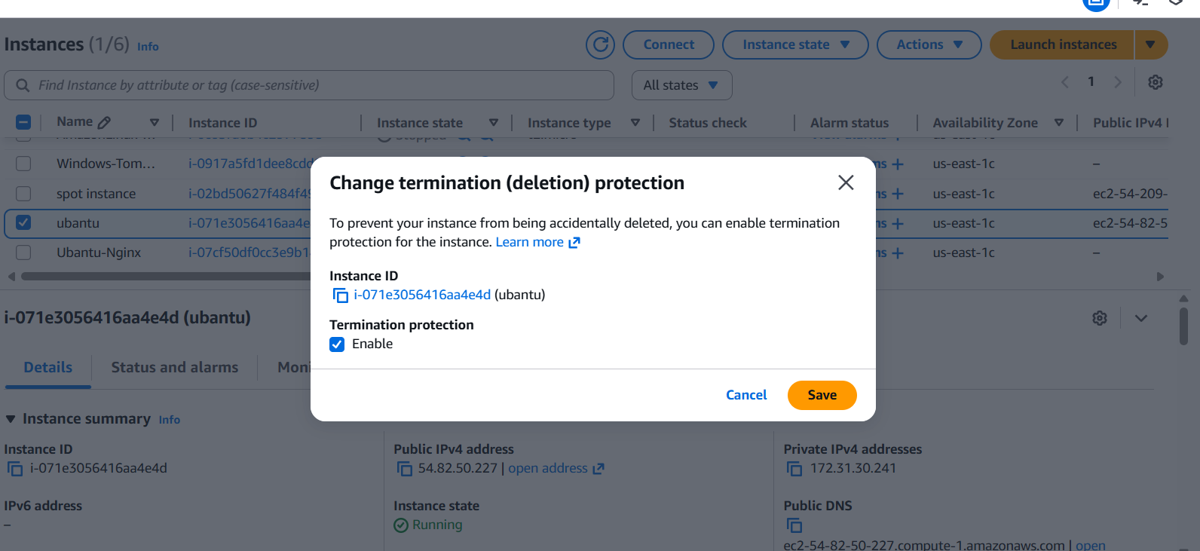

Task 8: Launch EC2 using AWS CLI
Step 1: Install AWS CLI
- Windows: Download from AWS site.
- Linux:
sudo apt install awscli
Step 2: Configure AWS CLI
Bash/git bash - aws configure
• Enter Access Key
• Secret Key
• Region (example: ap-south-1)
• Output format: json
Step 3: Launch EC2 using CLI
aws ec2 run-instances \
--image-id ami-xxxxxxxx \
--count 1 \
--instance-type t2.micro \
--key-name your-key-name \
--security-group-ids sg-xxxxxxxx \
--subnet-id subnet-xxxxxxxx

